Table of contents

Computer Architecture and Technology Convergence Assignment 2

Q1: Binary Arithmetic: 2

Q1.1. Add 11011 to 1011. Show your work (in particular, show where you get carries, and where you don't). You can check your work by translating the numbers into decimal, but I want to see the addition algorithm in base 2 instead of base ten. 2

Q1.2. Rewrite the following base-10 numbers as 8-bit two's complement integers: -31, & -59 2

Q1.3. What does the bit pattern 11101001 represent if you interpret it as an 8-bit two's complement integer? 3

Q1.4. Draw up the truth table for the circuit below (inputs are X and Y and outputs are B and D). From observing the result, what function do you think this circuit performs? 4

Q1.5. Draw the circuit diagram for the Boolean logic equation: (AB + C)D 4

Q2: Linux Assignment 5

Q2.1: Enter the commands below at the Linux terminal on the AWS VM (on which you completed your Linux Homework), and try to interpret the output. 5

Q2.2: Write the shell script using the Vim text editor 17

Q2.3 21

Q2.4: Write a shell script program that behaves like an Irish person offering a cup of tea. 22

Tree 24

References: 25

# Computer Architecture and Technology Convergence Assignment

Karolina Szafran-Belzowska

10/04/2019

## Q1: Binary Arithmetic:

### Q1.1. Add 11011 to 1011. Show your work (in particular, show where you get carries, and where you don't). You can check your work by translating the numbers into decimal, but I want to see the addition algorithm in base 2 instead of base ten.

11011(2) = 27(10)

1011(2) = 11(10)

100110(2) = 38(10)

|  |  |  |  |  |  |  |
| --- | --- | --- | --- | --- | --- | --- |
| 1 | 1 |  | 1 | 1 |  | carry |
|  | 1 | 1 | 0 | 1 | 1 |  |
|  | 0 | 1 | 0 | 1 | 1 |  |
| 1 | 0 | 0 | 1 | 1 | 0 |  |

### Q1.2. Rewrite the following base-10 numbers as 8-bit two's complement integers: -31, & -59

**“-31”**

**Step 1 :** Convert 31 to binary.

31/2 = 15 (1)

15/2 = 7(1)

7/2 = 3(1)

3/2 = 1(1)

½ = 0 (1)

31(10) = 00011111(2)

**Step 2:** Flip the bits

11100000

**Step 3:** Add 1

11100000

1 +

11100001

**Therefore** -31(10) = 11100001(2)

**“-59”**

**Step 1 :** Convert 59 to binary.

59/2 = 29(1)

29/2 = 14(1)

14/2 = 7(0)

7/2 = 3(1)

3/2 = 1(1)

½ = 0(1)

59(10) = 00111011(2)

**Step 2:** Flip the bits

11000100

**Step 3:** Add 1

11000100

1 +

11000101

**Therefore** -59(10) = 11000101(2)

### Q1.3. What does the bit pattern 11101001 represent if you interpret it as an 8-bit two's complement integer?

The bit pattern 11101001 represents the negative integer. “1” at the beginning stands for the negative integers and it represents the integers from –1 to

–128.

1. 11101001 (2)it’s the binary representation of a negative integer,

on 8 bits.

1. Change all the bits in binary - replace the bits set on 1 with 0’s and the bits on 0 with 1’s.

00010110

1 +

00010111

1. Multiply each bit by its corresponding power of 2 and add all the the terms up:

0 * 27 = 0

0 * 26 = 0

0 * 25 = 0

1 * 24 = 16

0 * 23 = 0

1 * 22 = 4

1 * 21 = 2

1 * 20 = 1

23 (10)

1. So, 11101001 (2)  = -23 (10)

### Q1.4. Draw up the truth table for the circuit below (inputs are X and Y and outputs are B and D). From observing the result, what function do you think this circuit performs?

**XOR**

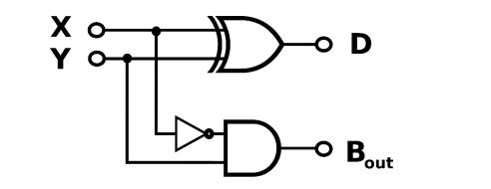

**NOT**

**AND**

**D = X Φ Y**

**B = X * Y**

**The Truth Table:**

|  |  |  |  |
| --- | --- | --- | --- |
| **X** | **Y** | **D** | **B** |
| 0 | 0 | 0 | 0 |
| 0 | 1 | 1 | 1 |
| 1 | 0 | 1 | 0 |
| 1 | 1 | 0 | 0 |

This Circuit performs a half subtraction operation on two binary digits. It’s a combinational circuit. The half subtraction produces a sum and borrows bit for the next stage.

### Q1.5. Draw the circuit diagram for the Boolean logic equation: (AB + C)D

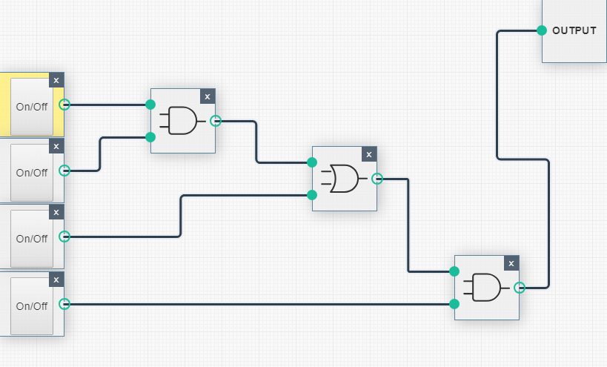

**D**

**C**

**B**

**A**

**(AB+C)D**

**AB +C**

**AB**

## Q2: Linux Assignment

### Q2.1: Enter the commands below at the Linux terminal on the AWS VM (on which you completed your Linux Homework), and try to interpret the output.

**Commands:**

* echo hello world
* passwd
* date *
* hostname *
* arch *
* uname -a *
* dmesg | more (you may need to press q to quit)
* uptime *
* whoami *
* who *
* last
* finger *
* w *
* top * (you may need to press q to quit)
* echo $SHELL
* echo {con,pre}{sent,fer}{s,ed}
* man ls (you may need to press q to quit)
* man who (you may need to press q to quit)
* clear
* cal 2000
* cal 9 1752 (do you notice anything unusual. Why is this the case?)
* yes please (you may need to press Ctrl-c to quit)
* time sleep 5
* history*

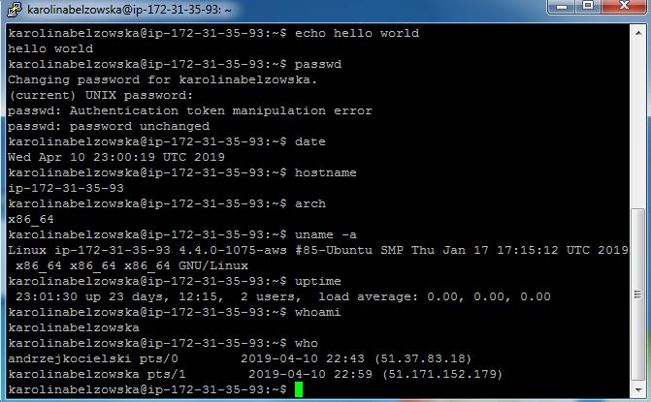

1. **Command “echo hello world”**

Displays a line of text : “hello world”

2. **Command “passwd”**

Displays a command to change the user’s password.

3. **Command “date”**

Shows the current date and time.

4. **Command “hostname”**

Shows IP, (system’s DNS name).

5. **Command “arch”**

Displays the architecture of the current host (machine hardware name).

X86_64 – for x86 64-bit architecture.

6. **Command “uname –a”**

It shows us kernel’s name, hostname, Kernel’s release, Kenel’s Version,

machine hardware name and Operating System’s name.

Here: Linux ip-172-31-35-93 4.4.0-1075-aws #85-Ubuntu SMP Thu Jan 17 17:15:12 UTC 2019 x86_64 x86_64 x86_64 GNU/Linux

7. **Command “uptime”**

Displays how long the system has been running, how many users are

currently logged on and the system load averages for the past 1, 5 and 15

minutes.

8. **Command “whoami”**

Shows current user.

Here: karolinabelzowska

**9. Command “who”**

Lists all users. It also shows date, time and terminal they are logged in.

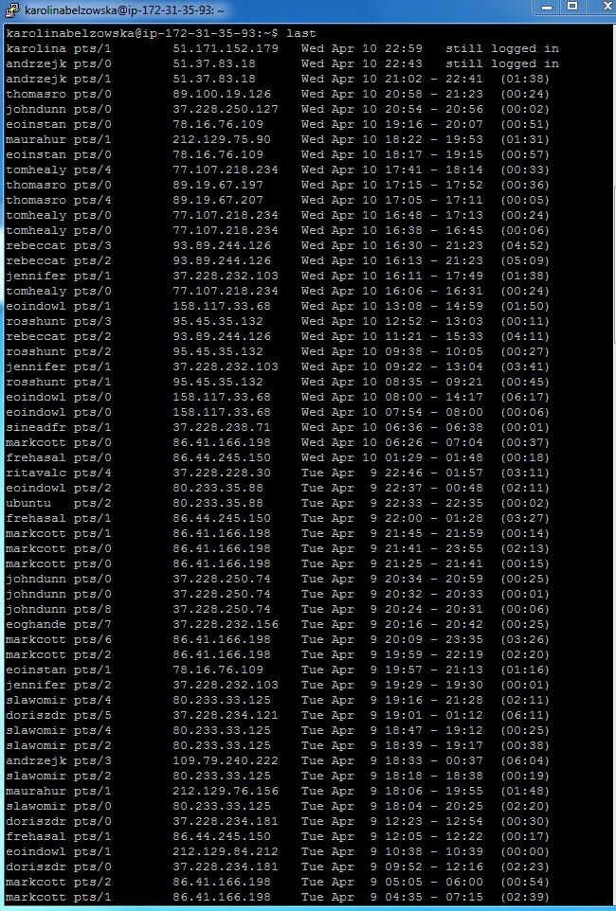

**10. Command “last”**

Displays the list of last logged in users. The very last ones appear on the top.

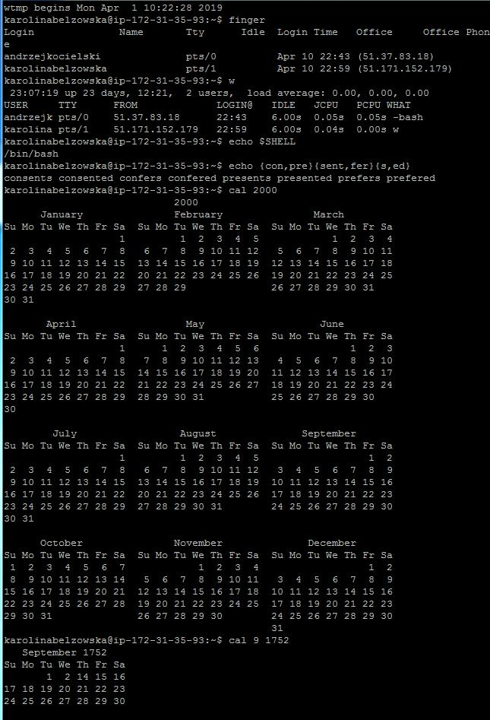

**11. Command “finger”**

Displays informations about users and it’s just an entry for each user

currently logged into the system.

**12. Command “w”**

Shows who is logged on and what they are doing.

Here: andrzejk and me – karolinabelzowska

**13. Command “echo $SHELL”**

Shows current shell that is being used.

**14. Command “echo {con,,pre}{sent,fer}{s,ed}”**

Shows the combination of all possible words.

**15. Command “cal 2000”**

Shows the calendar of year 2000.

**16. Command “cal 9 1752”**

Shows the calendar of September 1752.

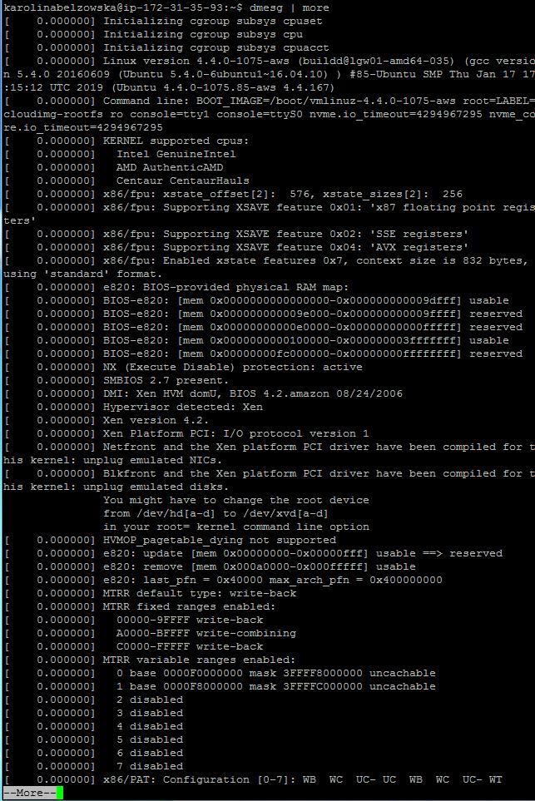

**17. Command “dmesg | more”**

Shows the message buffer of the kernel.

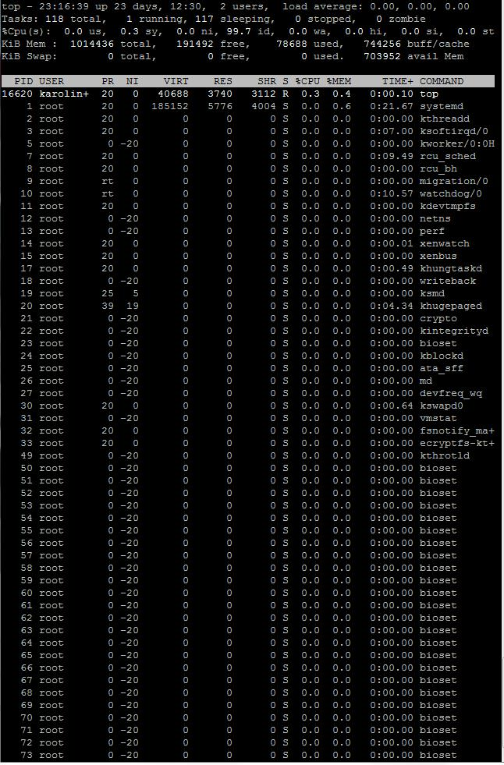

**18. Command “top”**

Shows linux tasks.

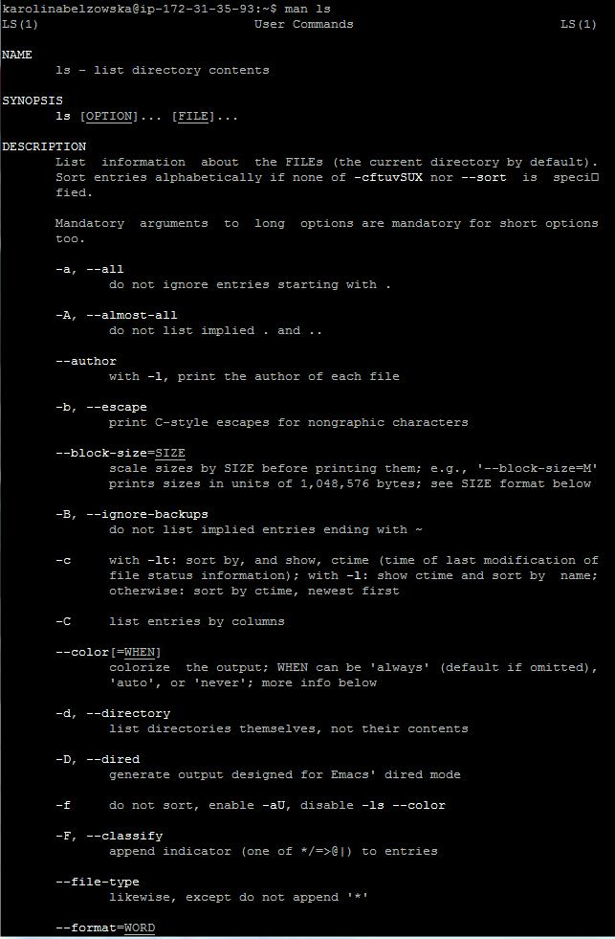

**19. Command “man ls”**

Displays manual page of ls command. Ls command give a list of directory contents.

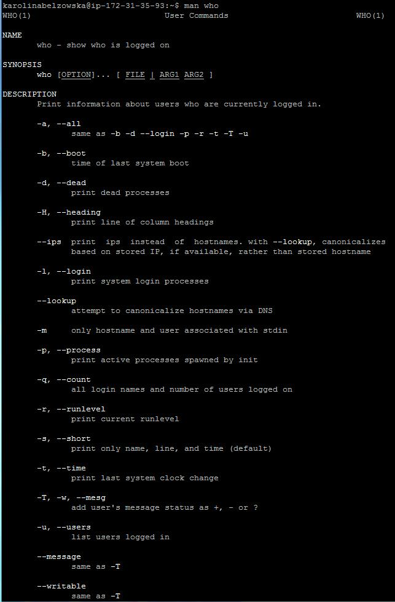

**20. Command “man who”**

Shows a manual page of who command (who is logged on)

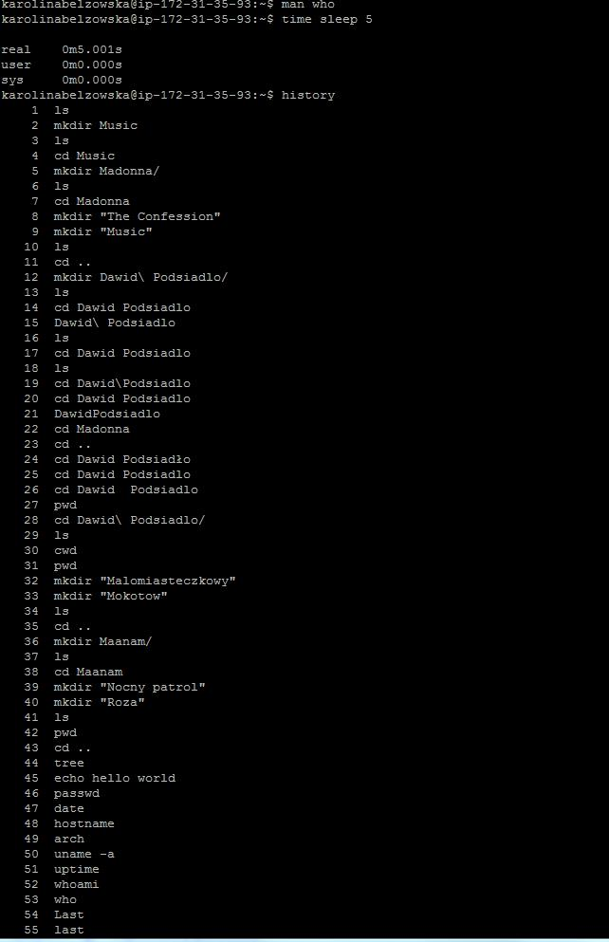

**21. Command “time sleep 5”**

Shows that the command will make my terminal pause for 5 seconds before returning to the command line.

**22. Command “history”**

Shows the history of all commands which were typed in terminal.

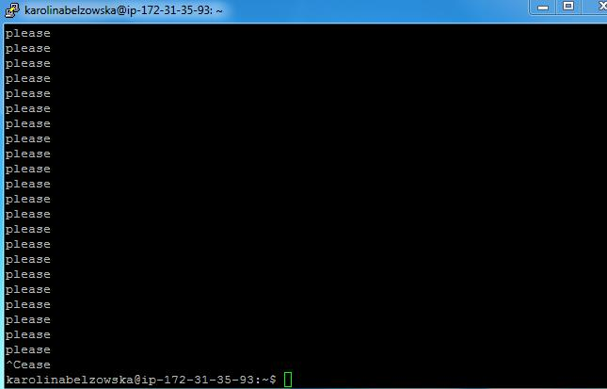

**23. Command “yes please”**

It continuously prints “please”.

Ctrl C clears terminal.

### Q2.2: Write the shell script using the Vim text editor

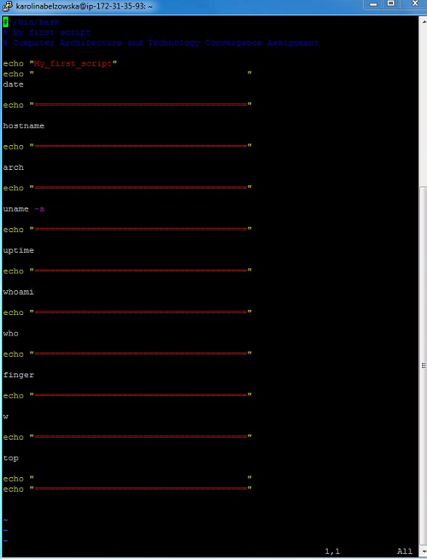

And History:

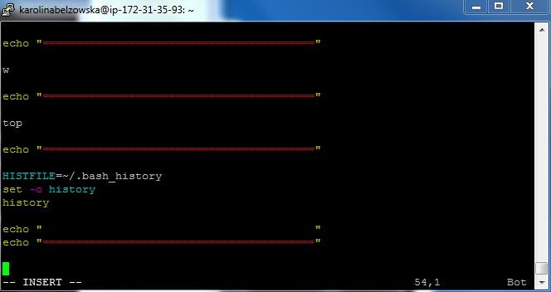

### 

Then I created “.txt” fie:

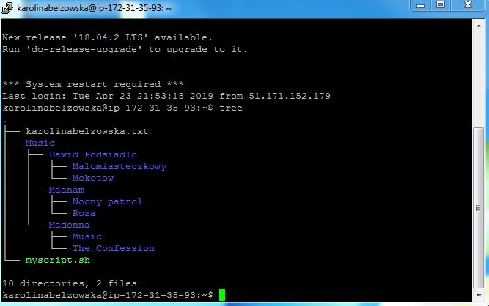

The contest of karolinabelzowska.txt file:

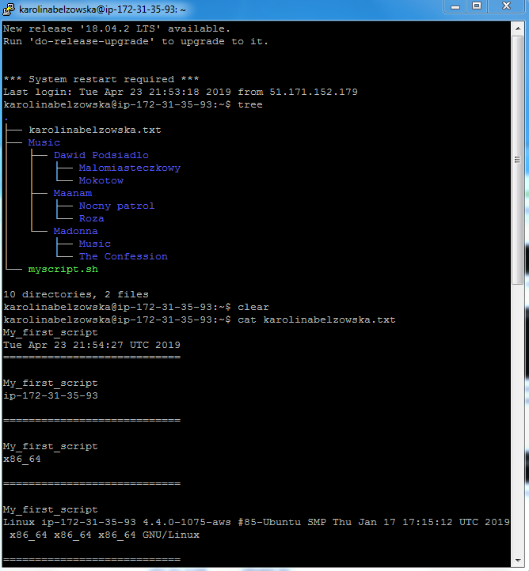

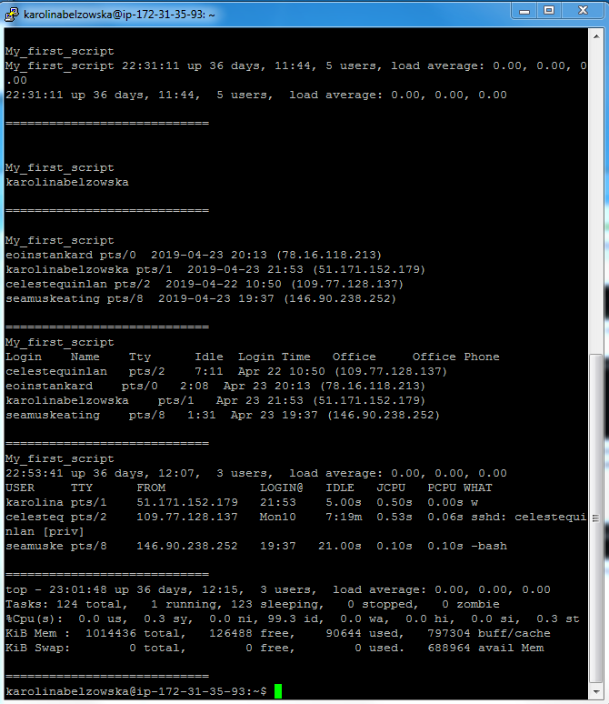

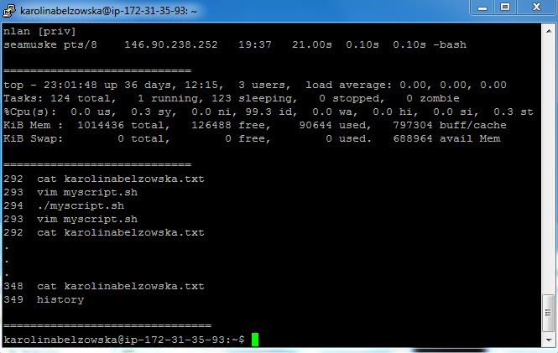

### Q2.3

#### Q2.3.1: Change the access permissions using the “chmod” command

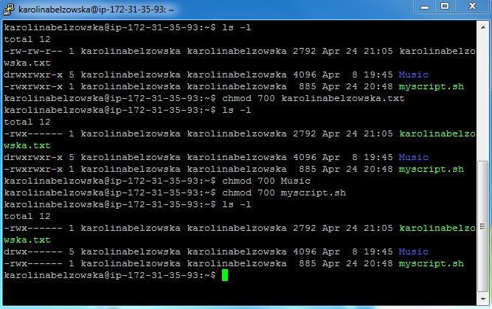

#### Q2.3.2: An online IP location service to determine the city and country where the VM is located

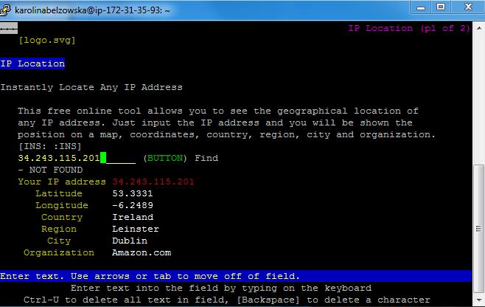

### Q2.4: Write a shell script program that behaves like an Irish person offering a cup of tea.

### 

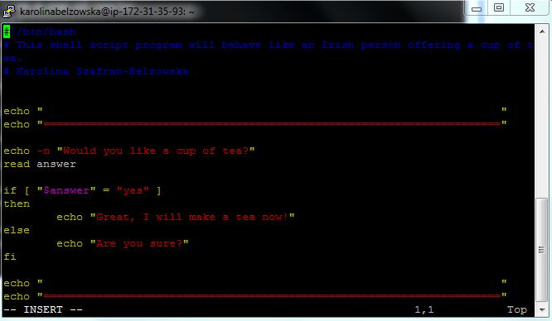

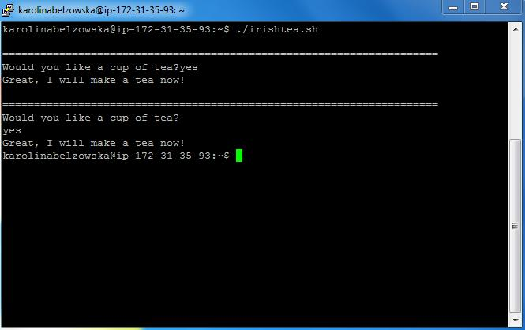

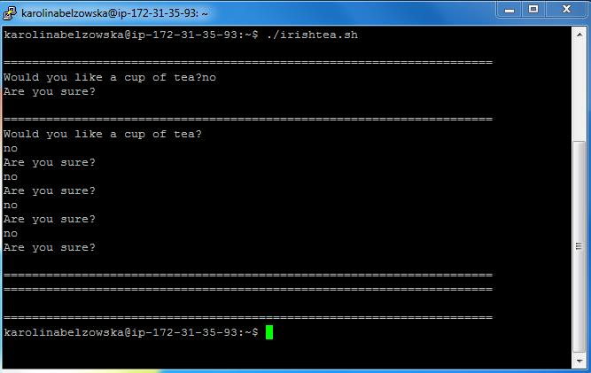

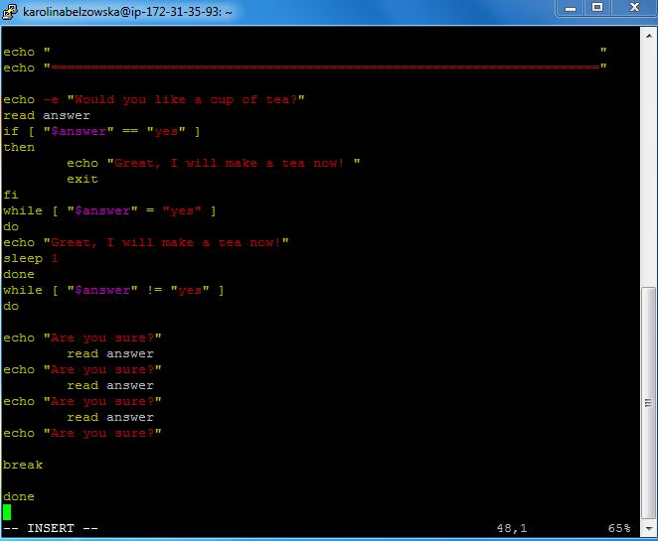

## Tree

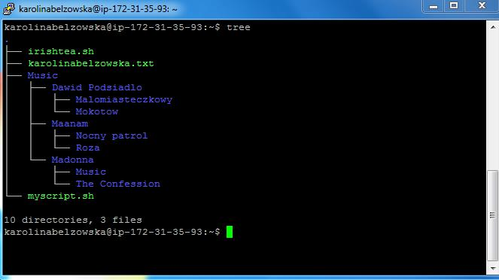

## References:

<https://www.cyberciti.biz/faq/save-file-in-vi-vim-linux-apple-macos-unix-bsd/>

<http://linuxcommand.org/lc3_wss0010.php>

<https://unix.stackexchange.com/questions/47584/in-a-bash-script-using-the-conditional-or-in-an-if-statement>

<https://stackoverflow.com/questions/13593771/repeat-command-automatically-in-linux>

<https://linuxhint.com/bash-while-loop-examples/>

<https://stackoverflow.com/questions/18488651/how-to-break-out-of-a-loop-in-bash>

<https://unix.stackexchange.com/questions/184631/bash-ubuntu-strings-in-while-loops>

<https://www.youtube.com/watch?v=IvHt_S3aYG4>

<https://www.tutorialspoint.com/unix/unix-basic-operators.htm>